**KAMPALA PARENTS’ SCHOOL 2004**

**END OF YEAR EXAMINATION, 2018**

**MATHEMATICS - P.3**

**TIME: 2Hrs 30Mins.**

**NAME: ___________________________________ AD. NO.______________ STREAM: __**

**SECTION A (40 MARKS)**

1. **Add:** 3 + 7 =

1. Given that P = {b, e, a, t}. Find n(P)



1. If represents 5 cups. How many cups are represented by ?
2. What do we call a shape with three sides?

________________________________

1. Draw a cone in the space provided below.
2. Write 1 in words.

2

__________________________

1. Write “two hundred forty eight” in figures.
2. Fill in the missing numbers in the sequence?

101, 201, 301, _____, 501, _____

1. **Work out:** y + 8 = 12
2. If the cost of a pen is shs.300, find the cost of 3 similar pens.

1. Draw a set symbol for matching sets.
2. Convert 3 metres to centimetres.

1 metre = 100cm

1. How many days are in 4 weeks if a week has 7 days?
2. Tell the time.

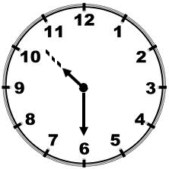

1. **Work out:** 3 0

- 1 9_

________

1. Which number has been shown below?



1. Find the total distance around the figure below.

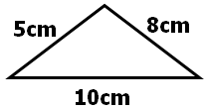

1. Share 12 sweets among 4 boys. How many sweets will each boy get?
2. Which day of the week comes after Sunday?
3. Expand 348 using values.

**SECTION B (60 MARKS)**

1. Set X = {m, e, n} Set Y= {g, o, n, e}
2. Represent the above information on the Venn diagram below. (2mks)

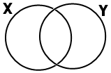

1. Find
2. n(X) = _______________ (1mk)
3. X ∪ Y = ________________ (1mk)
4. **Work out:** (2mks@)
5. + 8 = 10
6. z x 3 = 9
7. m ÷ 2 = 5
8. - 8 = 3
9. a) **Draw these shapes.** (1mk@)

|  |  |
| --- | --- |
|  |  |
| triangle | cylinder |

b) **Name these shapes below.** (1mk@)

|  |  |
| --- | --- |
|  |  |
|  |  |

1. **Work out:** (1mk@)



1. 2 24
2. 6 0 0 c) 8 8 2

- 4 7 7_ + 3 5 2_

_______ _______

1. 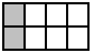a) Name the shaded fraction. (1mk)

=

b) What fraction is unshaded? (1mk)

c) Subtract the shaded fraction from the

unshaded. (2mks)

1. **Use >, < or = to complete correctly.**
2. 2 + 2 ….……….. 6 - 2 (1mk)
3. 13 ……….…… 31 (1mk)
4. 3 × 0 ….……….. 9 × 0 (1mk)
5. 1 ………..… 1 (1mk)

2 4

1. Lyn is 24 years old. Bill is 42 years old.
2. Who is younger? (1mk)
3. Find their total age. (2mks)
4. Subtract Lyn’s age from Bill’s age.

(2mks)

1. **Match correctly.** (1mk@)
2. 10 + 5 5
3. 10 ÷ 2 10
4. 10 × 2 15
5. 12 - 2 20
6. **Study the price list below and answer**

**questions correctly.**

|  |  |
| --- | --- |
| **Item** | **Price** |
| water  sugar  soda  cake | shs.1000  shs.3000  shs.1000  shs.500 |

1. What is the cheapest item on the list?

(1mk)

1. How much will Oscar pay for sugar and water? (2mks)
2. Which two items cost the same amount of money? (1mk)

______________ and _______________

1. If Liz buys all the items, how much money will she pay? (2mks)
2. **Use +, -, x or ÷ to complete correctly.**
3. 4 …….………… 2 = 8 (1mk)
4. 6 …….………… 2 = 8 (1mk)
5. 10 …….………… 2 = 8 (1mk)
6. 16 …….………… 2 = 8 (1mk)
7. a) Find the difference between 3 and 5.

(2mks)

b) What is the sum of 6 and 9? (2mks)

c) Find the product of 7 and 11. (2mks)

1. **Some girls were given flowers as follows.**

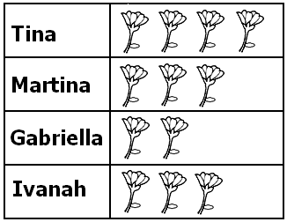

1. Who was given the highest number of flowers? (1mk)

________________________________

1. Who got the smallest number of flowers? (1mk)

________________________________

1. Which two girls got the same number of flowers? (2mks)

________________________________

1. How many flowers were given to Gabriella and Ivanah altogether? (2mks)
2. How many flowers were given out altogether? (2mks)

**\*\*\* Good Luck! \*\*\***